OFFICIAL LEAGUE ROSTER - BASKETBALL

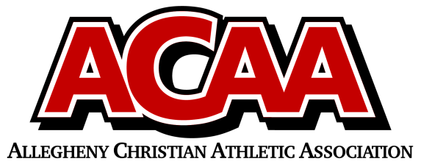

School Name: Great Commission School

Team Colors: Royal Blue & White

Overall Wins ___ Losses ____ Ties ___

ACAA Wins ___ Losses ____ Ties ___ OPPONENT: __________________________

DATE: _________

|  |  |  |  |  |  |
| --- | --- | --- | --- | --- | --- |
| **Number** | **Name** | **Year** | **Position** | **Height** | **Homeschool** |
| 0 | Charlie Lohsl | 12 | G | 5’6 |  |
| 35 | Kyle Rodgers | 12 | F | 6’2 |  |
| 20 | Landyn Summers | 12 | G | 6’ |  |
| 1 | Elijah Best | 11 | G | 5’8 |  |
| 3 | Alex Guise | 11 | F | 6’1 |  |
| 2 | Camden Hileman | 11 | F | 6’ |  |
| 24 | Greyson Miller | 11 | G | 5’11 | yes |
| 34 | Marco Palazzi | 11 | F | 6’2 |  |
| 10 | Ian Grissinger | 10 | G | 5’3 |  |
| 21 | Zach Best | 9 | F | 5’8 |  |
| 11 | Joel Lohsl | 8 | G |  |  |
|  |  |  |  |  |  |
|  |  |  |  |  |  |
|  |  |  |  |  |  |
|  |  |  |  |  |  |
|  |  |  |  |  |  |
|  |  |  |  |  |  |
|  |  |  |  |  |  |
|  |  |  |  |  |  |
|  |  |  |  |  |  |
|  |  |  |  |  |  |
|  |  |  |  |  |  |
|  |  |  |  |  |  |
|  |  |  |  |  |  |
|  |  |  |  |  |  |

Head Coach: AARON BENSON

Asst. coach: ZETH OSBORN

STATS: PEYTON HICKS

AD: JULIE LOHSL

Official ACAA League Team Roster. to be submitted to the scorer’s table before each game.